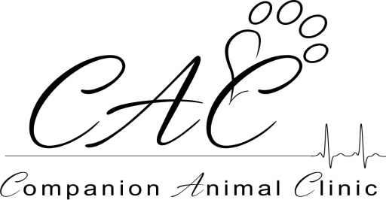
Where Wise Pets Bring Their People!
541-747-2307

Welcome to Companion Animal Clinic! We are excited to meet you and your pet. We know how busy you are and how stressful it can be for your pet to be in our lobby so we try hard to keep to our schedule so you do not have to wait longer than you and your pet would appreciate! Below are a few of our policies to help keep to our schedule and answer common questions we are asked:

- By law, every pet needs to have a current yearly exam in order to continue to fill prescription medications, fill prescription food, fill prescription flea products, and schedule technician appointments.

- Cancellations are required within 12 hours of the scheduled appointment. A “no show” fee may be applied to any account in which an appointment was scheduled but the client/patient did not show.

- Any appointment that arrives more than 10 minutes late may be rescheduled. If you know you are going to be late, please call to see if we can still “work you in” or if your appointment needs to be rescheduled.

- A 24 hour notice is required for any medications needing to be filled. If medications need to be filled the same day they are called in, an “urgent medication” fee may be applied to your account and expected to be paid at the time of medication pick up.

- By FDA regulation, prescribed medications, flea products, shampoos etc, are NOT returnable. Once these products leave the building, we cannot take them back.

- Payment is expected at the time of service by means of cash, Visa, MasterCard, Discover, or CareCredit. We do not accept checks and DO NOT bill.

Thank you for entrusting us with your pet’s health care needs!

